Special Education Services

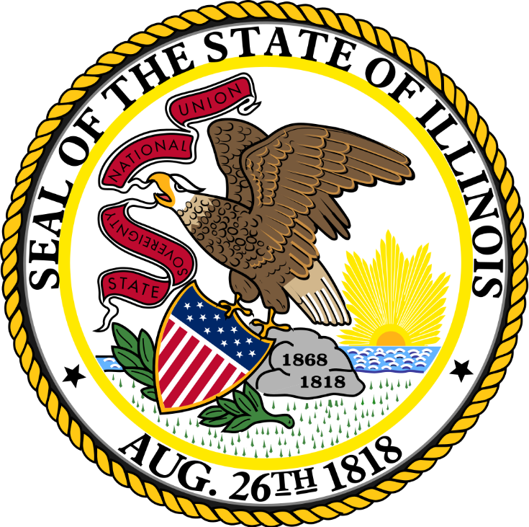

Local Wellness Policy

Table of Contents

Preface…………………..…………………………….....………………………………….. 1
Wellness Policy Committee……………………………………………………….… 2
Wellness Policy Leadership…………………….……………………….. 2
Wellness Policy Committee Members………………………………. 2
Wellness Policy Committee Responsibilities…………………....……….….. 3
Public Involvement………………………………………………..…………3
Assessments.………………………………………………………………...… 3
Updates………………….……………………………………………………….. 4
Records………….…………………………………….…………………………. 4
Nutrition……………………………………………………………………….……………. 5
Nutrition Standards………………………………………………………… 5
Nutrition Education................................................................................. 7
Nutrition Promotion……………………..…………………………………. 8
Marketing……………….………………………………………………………. 9
Physical Activity……………………………………………………………………… 10
Physical Education..……………………….…………………………………10
Other Opportunities for Physical Activity......................................10
Physical Activity Promotion……...……..…………….…………………10
Other School-Based Activities……………….……………...……………………. 12
Preface
In accordance with 7 CFR 210.31(c), a Local Education Agency that participates in the National School Lunch Program (NSLP) and/or School Breakfast Program (SBP) must establish a Local School Wellness Policy for all schools under its jurisdiction. As of June 30, 2017, Local Wellness Policies must meet the minimum requirements set forth in the Final Rule: Local School Wellness Policy Implementation Under the Healthy, Hunger-Free Kids Act of 2010.
Local Wellness Policies are a valuable tool in the promotion of student health and wellness through the NSLP and SBP. Schools play an essential role in preparing students for successful futures, and proper nutrition and physical activity are key to creating constructive learning environments. Local Wellness Policies provide guidance to further support schools efforts to provide students with a successful and healthy future.

Wellness Policy Committee

Wellness Policy Leadership
Name, Title of School Official #1
Contact: Jason Kudelka

Wellness Policy Committee Members
Name, Title of Member #1
Contact: Brian McGowan

Name, Title of Member #2
Contact: Michelle Torres

Name, Title of Member #3
Contact: Viver Ballard

Name, Title of Member #4
Contact:

Name, Title of Member #5
Contact:

Wellness Policy Committee Responsibilities

Public Involvement

The Local Education Agency permits and encourages public involvement in Local Wellness Policy development, implementation, updates, and reviews. Therefore, the LEA shall invite a variety of stakeholders within the general public to participate in Local Wellness Policy processes. The following methods of communication will be utilized to notify the general public of the opportunity to participate in these processes:
- Organization website and shared via annual CEP notification letter.
Assessments
Under the Healthy, Hunger-Free Kids Act of 2010, assessments of the Local Wellness Policy must occur no less than every three years. Special Education Services shall conduct assessments of the Local Wellness Policy every three years, beginning in 2019 and occurring every three years thereafter. These assessments will:
- Ensure the wellness policy is in compliance with USDA, State, and Local rules and regulations
- Compare the LEA’s wellness policy to model wellness policies
- Measure the progress made in achieving the goals as outlined in the LEA’s wellness policy

Updates
The Wellness Policy Committee must update the Local Wellness Policy as appropriate in order to fit the needs and goals of the Local Education Agency. The LEA shall make the following available to the public:
- The Local Wellness Policy, including any updates to the policy, on a yearly basis
- The triennial assessment, including progress toward meeting the goals outlined in the wellness policy
Through the following channels:
- Organization website.

Records
The Local Education Agency shall maintain record of the Local Wellness Policy. This includes keeping a copy of the current wellness policy on file and maintaining documentation of the following actions:
- The most recent assessment of the policy
- Availability of the wellness policy and assessments to the public
- Reviews and revisions of the policy, including the individuals involved and the efforts made to notify stakeholders of their ability to participate in the process
Nutrition
The Local Education Agency recognizes the important role nutrition plays in academic performance as well as overall quality of life. The National Education Association references numerous articles supporting the effects of nutrition on the classroom, for example, hunger often has a negative impact on students’ success, attendance, and behavior.
According to the Centers for Disease Control and Prevention, approximately 18.5 percent of the nation’s youth was considered obese in 2015-16. This percentage increased 1.3 percent when compared to the previous year. Conversely, 15.7 percent of American families experienced food hardship in 2017. Through participation in the U.S. Department of Agriculture’s School Nutrition Programs, the LEA commits to serving nutritious meals to students in order to prevent both overconsumption of nutrient-poor foods and food insecurity to give students the best chance to succeed inside and outside the classroom.
Nutrition Standards
Meals
All reimbursable meals served for the purposes of the National School Lunch Program (NSLP) and School Breakfast Program (SBP) must meet or exceed USDA nutrition standards and regulations. This includes meeting standards for each of the meal pattern components (i.e. Grains, Meat/Meat Alternates, Fruits, Vegetables, and Milk) as well as meeting or exceeding the limitations set for calories, sodium, saturated fat, and trans fat.
Competitive Foods
N/A
Other Foods and Beverages

The following policy refers to all foods and beverages provided, but not sold to students. The Local Education Agency will make Smart Snack options available for reward and celebration purposes. More than 25 percent of children’s daily calories may come from snacks, therefore, providing Smart Snacks allows for a more nutrient-dense calorie intake options.
Fundraisers
N/A
Nutrition Education
The Local Education Agency shall include nutrition education within the health education curriculum and integrate nutrition education into other core subjects, as appropriate. Various grade levels and curriculums shall use nutrition education information, research, and materials from the following resources:
- Dietary Guidelines for Americans, MyPlate, Team Nutrition, and FoodMASTER .
- MyPlate
- ETR Healthsmart Curriculum
Nutrition Promotion
The District shall implement nutrition promotion techniques through multiple channels, including the cafeteria, classroom, and home.
The District shall make cafeteria menus and nutrition information available through the following platforms:
- Menus are posted at the site and available upon request.
The Smarter Lunchrooms Movement uses behavioral economics to positively influence food choices made by children. The evidence-based techniques implemented through the Movement have been proven to increase children’s consumption of nutritious foods. The District shall participate in the Smarter Lunchrooms Movement by utilizing the Smarter Lunchrooms 60-point Scorecard and other educational and promotional tools. The District shall implement the following Smarter Lunchrooms techniques:
- [List Smarter Lunchrooms techniques used by the District. For information on the Smarter Lunchrooms Movement and examples of these techniques, please review the Smarter Lunchrooms Movement website and Scorecard.]
- Sliced, cut, or single serving fruit is offered.
- Vegetables are available on all lunch serving lines.
- Both hot and cold vegetables are offered during the school week.
- White milk available during meal service and offered on all serving lines.
- Students can preorder lunch in the morning (select sites).
- Students are prompted to select fruit or vegetables to complete their meal.
- Staff smile and greet students during meal service.
- Cleaning supplies are not visible during meal service.
- Proper lighting is provided in cafeterias and areas for meal service/consumption.
- Students can volunteer in the lunchroom (select sites).
Farm to School efforts positively impact School Nutrition Programs by serving fresh and nutritious food items. Additionally, Farm to School programs have been linked to increased consumption of fruits and vegetables. The District shall participate in Farm to School activities whenever possible, such as farm-based field trips, school gardens, and agricultural education.
Marketing
The Local Education Agency will prohibit the marketing and advertising of all foods and beverages on the school campus (i.e. locations on the school campus that are accessible to students) during the school day (i.e. the midnight before to 30 minutes after the end of the school day). The marketing standards described above apply, but are not limited to, oral, written, and graphic statements made for promotional purposes. Items subject to marketing requirements include, but are not limited to, posters, menu boards, vending machines, coolers, trash cans, scoreboards, and other equipment.
Physical Activity
Physical activity is a key component of the health and well-being of all students. Physical activity lowers the risk for certain diseases, including obesity, heart disease, and diabetes. Physical activity also helps improve brain function, allowing students to perform better in school.
The Centers for Disease Control and Prevention recommends adolescents get at least 60 minutes of physical activity five days per week. Nearly 79 percent of school-age children fall short of meeting this requirement. The Local Education Agency recognizes this connection and commits to promoting and providing opportunities for physical activity during and outside the school day.
Physical Education
The LEA shall offer Physical Education class as follows:
- Spark P.E. curriculum
Other Opportunities for Physical Activity
The District shall include additional physical activity opportunities, outside of Physical Education class, during the school day through the following:
- Movement break activities from the Spark PE Curriculum
- Go Noodle (educational site that teaches everything through movement
The following opportunities for participation in school-based sports shall be offered to students each year:
- Basketball, football, softball, volleyball, and soccer teams are offered at various schools for middle school age and higher.
Physical Activity Promotion
The District shall promote physical activity through the participation in initiatives as appropriate.

Other School-Based Activities
Just as it takes a comprehensive curriculum to provide education to support students’ futures, the Local Education Agency’s wellness approach must also be comprehensive in its intent to provide students with the tools they need to live a healthy lifestyle. In order to further establish positive behaviors related to nutrition, physical activity, and health, the LEA commits to making additional wellness-based activities available to all students beyond the cafeteria and gymnasium.
The Local Education Agency shall offer other school-based activities to support student health and wellness, including coordinated events and clubs.

